OS LAB 10

TASK (FCFS):

CODE:

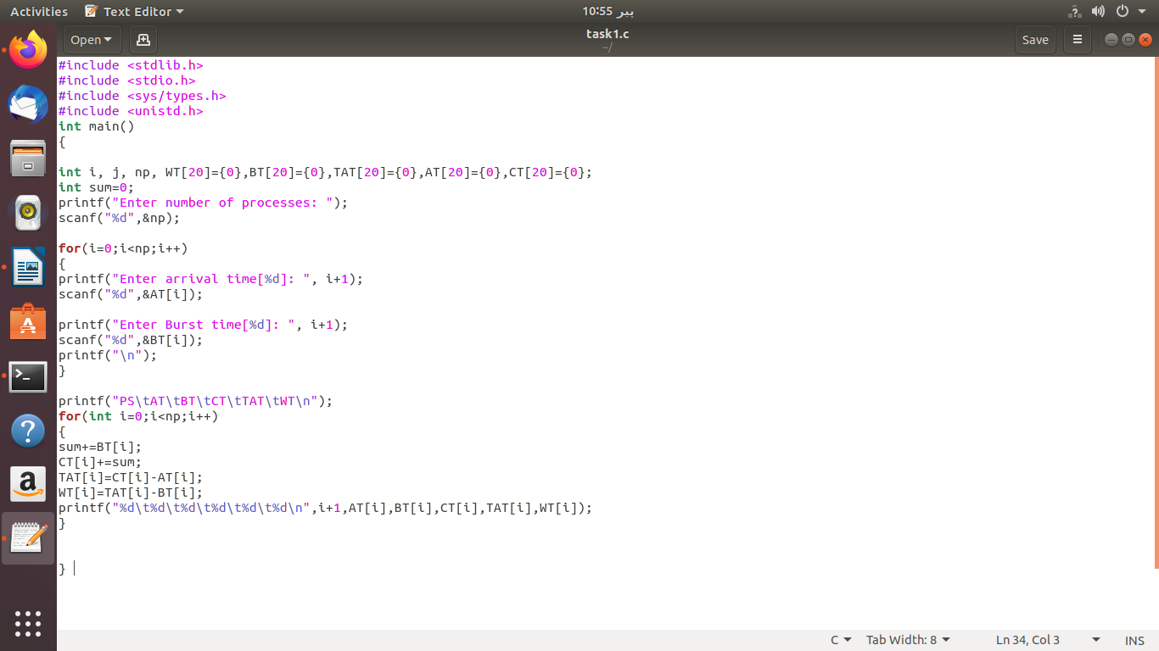

OUTPUT:

